OS Program

In-class writing assessment

Writing assessments will be made in the OTA classroom at designated times. Students will take the assessment in groups of up to 20 people.

Students will be given 20 minutes to write one paragraph on a question that is provided. Sample questions are:

* How would you define occupational therapy and what does this mean to you?
* Why do you want to become a COTA?
* What strengths do you have that will be an asset to you working in the field of occupational therapy?
* Describe a situation when you were helpful to another person.
* OT practitioners work with people at various stages in life – children, adults and older people. What age group do you think you would like to work with and why?
* Think of a job that you have had that you really enjoyed. What was the best part of it?
* What do you think is meant by this quote, “The heart is wheelchair accessible”?
* Show YouTube video clip – “She without an arm, he without a leg”. Ask student to write how they felt about watching it.
* What most attracted you to work in the field of health care?
* What do you think is important for us to know about you in considering your application?
* Write a paragraph about what this picture communicates to you. (we will interchange pictures)
* 
* 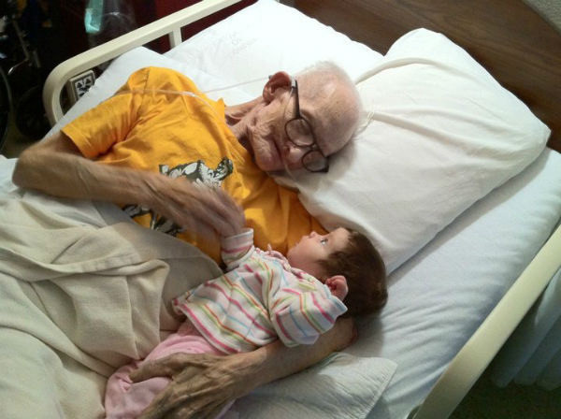
* What do you think of when you look at these father/son pictures?
* 

Grading rubric

|  |  |  |  |  |
| --- | --- | --- | --- | --- |
| Competency | Excellent 25 | Good 15 | Acceptable 10 | Poor 0 |
| Content | Demonstrates: Empathy  Insight  Caring attitude | Identifies own feelings | Information is more descriptive than feeling based | Information is not relevant or is unclear |
| Communication | Responses are grammatically correct (articles of speech, tense, prepositions, adverbs and nouns), and written in complete sentences. | Responses have 1-2 errors in grammar or spelling and are written in complete sentences. | Responses have more than 3 errors but meaning in easily understood. | Meaning of content lost due to grammatical errors |